Infrared Technology at Binder Home Inspections

Binder Home Inspections has been utilizing infrared technology for the last several years. At first, we utilized Flir One that simply attached to the iphone. It was a great little starter camera for the business however, times change and our technology specs required more. BHI placed the unit on Kijiji, and it was sold to a horse owner so she could check the horses’ temperature thermally! As technology grows so does www.binderhomeinspections.com.
The newer addition to our family (almost 2 years old now), is the Fluke Ti32. This is one of the finer infrared cameras on the market today. It is utilized by many professions presently. Building diagnostics – Home Inspectors, Building Design, and Contractors. Electrical and Mechanical Maintenance – Hydro Companies, and Product development and research. At Binder Home Inspections, we utilize the infrared technology in a variety of ways. This is the camera that we utilize at Binder Home Inspections. It has the capability of picking up heat loss, leaks within ductwork, air leaks due to poor insulation and caulking seals, missing insulation, attic airflow, overheated breakers and wires at the distribution panel, and many other uses to determine factors in your rising bill costs!
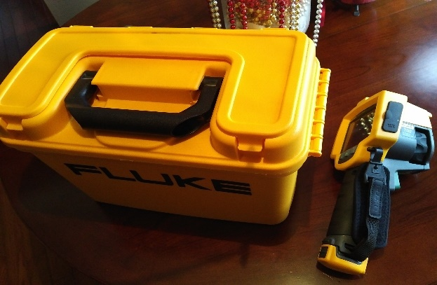
Heat loss is always a popular subject when dealing with your homes efficiency. There are many factors which contribute to the loss of heat and air conditioning within your homes environment. The first factor would be the R value within your homes attic and walls. Without infrared technology, it is near impossible to determine heat loss. The infrared camera will detect gaps and air infiltration within the stud walls of your home. A recent inspection at a home with flooding had revealed the gap between the floor space and its walls. The insulation was removed due to the floor being wet and wicking up into the vapor barrier and the insulation. The darker areas represent the colder air where the insulation had been removed.
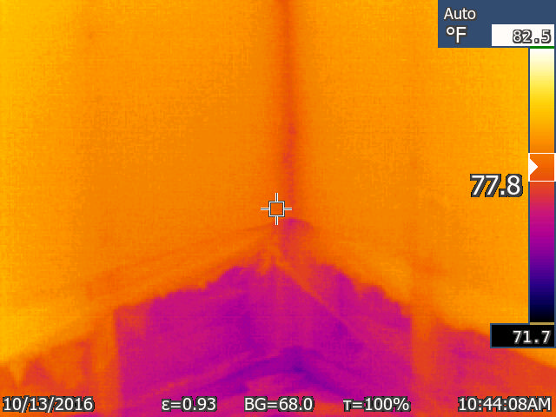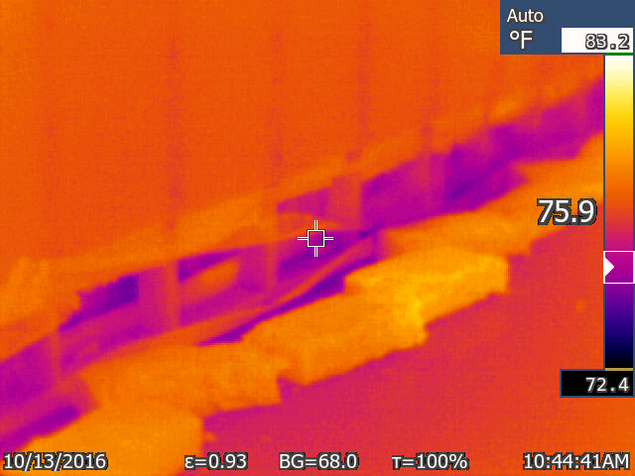
Just for interest, we wanted to add the next photos to our Binder Home Inspections blog. Upon entering this home, there was no furnace, boiler, heat pump or even gas/wood fireplace to mention. However, there were thermostats in every room on the main floor of the home. Turn up the thermostat and voila! The next photos explain the heat source – electric radiant heat within the ceilings. Not the most energy efficient system but, nonetheless the Fluke Ti32 found it.
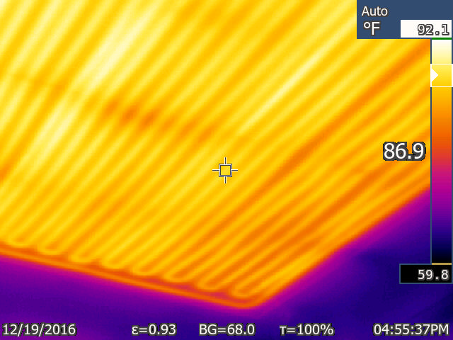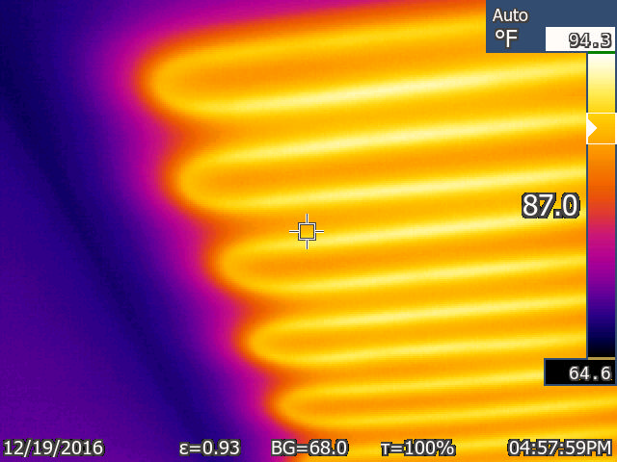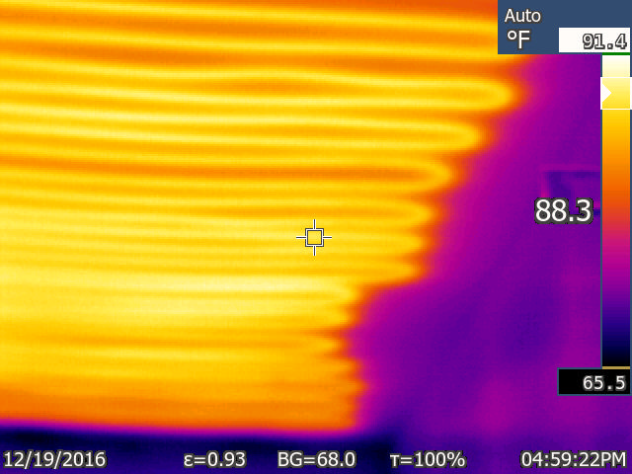
Home
The last few photos will give you other factors as to why www.binderhomeinspections.com utilizes infrared technology.

Heat loss through light fixtures. Breakers not overheating but, being utilized. Cold Zones
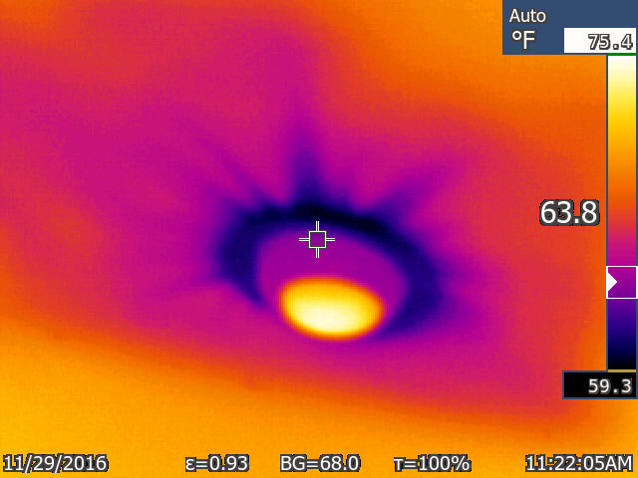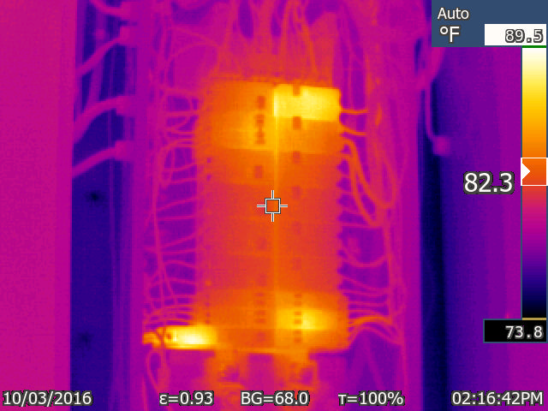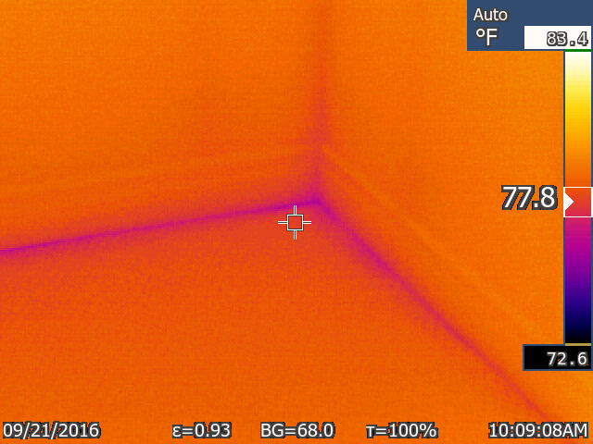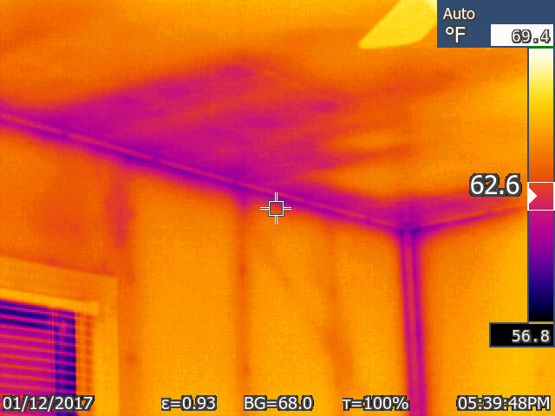
Thank you, for checking in to our Binder Home Inspections Blog section. Check back with www.binderhomeinspections.com often, for more updates and pertinent information that involves your home and its environment!
If you have any questions or would like to book an infrared inspection and/or home inspection please call/text 519-995-2067 or email john@binderhomeinspections.com Please like us on Facebook as well!
*We also have pricing for your seasonal inspections as well Spring/Fall, please ask for John Binder when booking! Thanks again….

